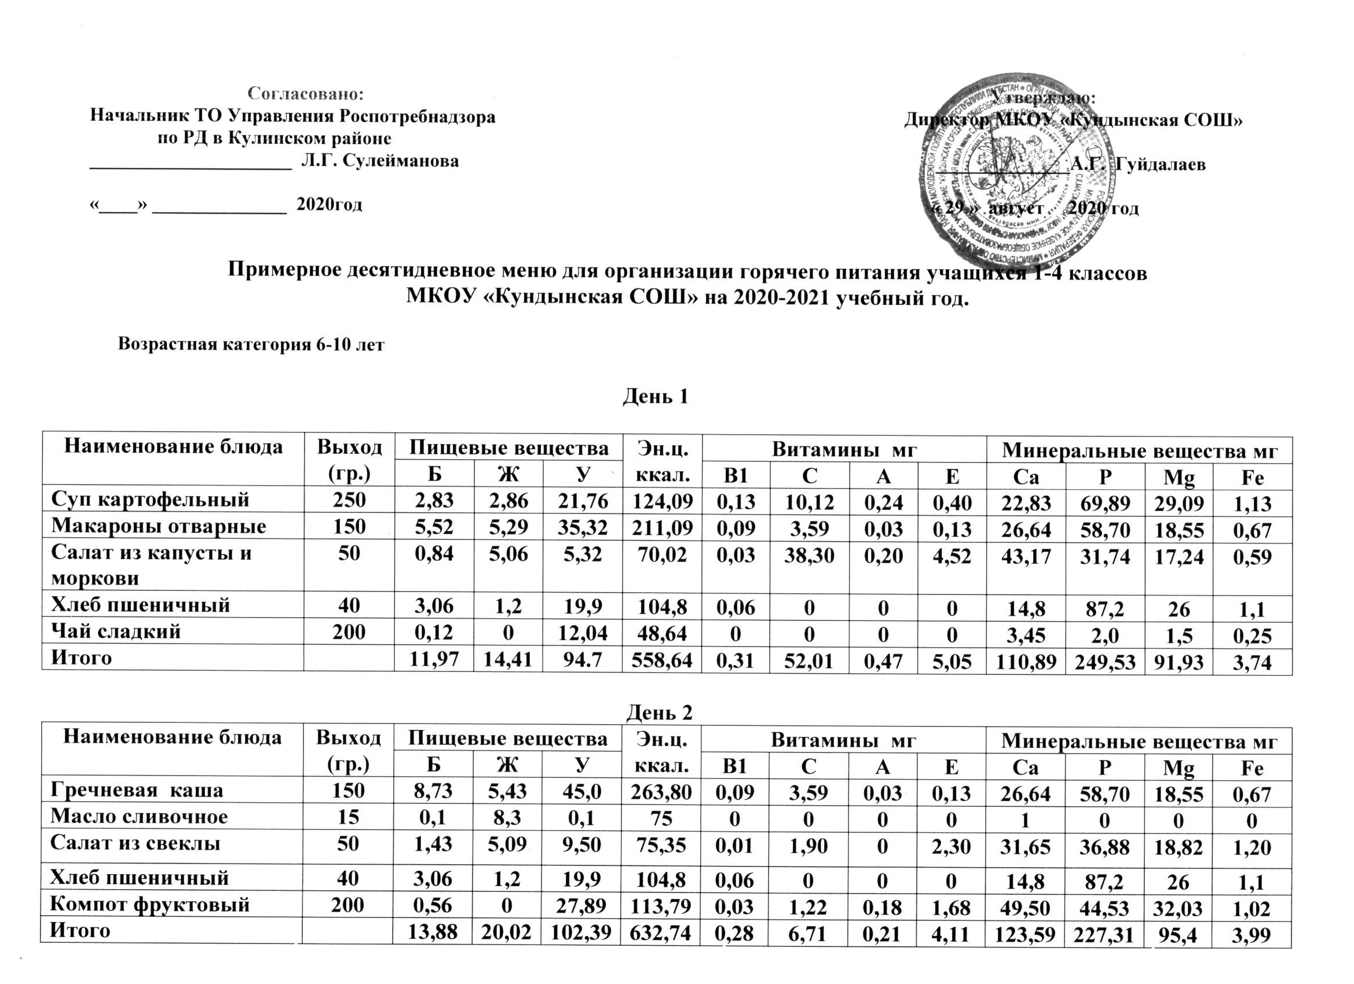

**День 3**

|  |  |  |  |  |  |  |  |  |  |  |  |  |  |
| --- | --- | --- | --- | --- | --- | --- | --- | --- | --- | --- | --- | --- | --- |
| **Наименование блюда** | **Выход**  **(гр.)** | **Пищевые вещества** | | | **Эн.ц. ккал.** | **Витамины мг** | | | | **Минеральные вещества мг** | | | |
| **Б** | **Ж** | **У** | **В1** | **С** | **А** | **Е** | **Са** | **Р** | **Мg** | **Fе** |
| **Суп гороховый** | **250** | **2,73** | **3,89** | **13,61** | **98,79** | **0,15** | **11,12** | **0,25** | **0,80** | **22,83** | **69,89** | **19,09** | **1,13** |
| **Макароны отварные** | **150** | **5,52** | **5,29** | **35,32** | **211,09** | **0,09** | **3,59** | **0,03** | **0,13** | **26,64** | **58,70** | **18,55** | **0,67** |
| **Салат из капусты и моркови** | **50** | **0,84** | **5,06** | **5,32** | **70,02** | **0,03** | **38,30** | **0,20** | **4,52** | **43,17** | **31,74** | **17,24** | **0,59** |
| **Хлеб пшеничный** | **40** | **3,06** | **1,2** | **19,9** | **104,8** | **0,06** | **0** | **0** | **0** | **14,8** | **87,2** | **26** | **1,1** |
| **Чай сладкий** | **200** | **0,12** | **0** | **12,04** | **48,64** | **0** | **0** | **0** | **0** | **3,45** | **2,0** | **1,5** | **0,25** |
| **Итого** |  | **12,27** | **15,44** | **86,19** | **533,34** | **0,33** | **53,01** | **0,48** | **5,45** | **110.89** | **249,53** | **82,38** | **3,74** |

**День 4**

|  |  |  |  |  |  |  |  |  |  |  |  |  |  |
| --- | --- | --- | --- | --- | --- | --- | --- | --- | --- | --- | --- | --- | --- |
| **Наименование блюда** | **Выход**  **(гр.)** | **Пищевые вещества** | | | **Эн.ц. ккал.** | **Витамины мг** | | | | **Минеральные вещества мг** | | | |
| **Б** | **Ж** | **У** | **В1** | **С** | **А** | **Е** | **Са** | **Р** | **Мg** | **Fе** |
| **Плов из отварной птицы** | **210** | **37,2** | **45,33** | **41,05** | **747,09** | **0,17** | **2,10** | **1,16** | **1,66** | **54,10** | **396,06** | **96,06** | **3,58** |
| **Винегрет овощной** | **50** | **1,26** | **10,14** | **8,32** | **129,26** | **0,04** | **5,34** | **0,20** | **4,54** | **21,40** | **39,91** | **18,03** | **0,75** |
| **Хлеб пшеничный** | **40** | **3,06** | **1,2** | **19,9** | **104,8** | **0,06** | **0** | **0** | **0** | **14,8** | **87,2** | **26** | **1,1** |
| **Компот из фруктов** | **200** | **0,56** | **0** | **27,89** | **113,79** | **0,03** | **1,22** | **0,18** | **1,58** | **49,50** | **44,53** | **32,03** | **1,02** |
| **Итого** |  | **42,08** | **56,67** | **97,16** | **1094,94** | **0,30** | **8,66** | **1,54** | **7,78** | **139,8** | **567,7** | **172,13** | **6,45** |

**День 5**

|  |  |  |  |  |  |  |  |  |  |  |  |  |  |
| --- | --- | --- | --- | --- | --- | --- | --- | --- | --- | --- | --- | --- | --- |
| **Наименование блюда** | **Выход**  **(гр.)** | **Пищевые вещества** | | | **Эн.ц. ккал.** | **Витамины мг** | | | | **Минеральные вещества мг** | | | |
| **Б** | **Ж** | **У** | **В1** | **С** | **А** | **Е** | **Са** | **Р** | **Мg** | **Fе** |
| **Суп с макаронами** | **250** | **2,83** | **2,86** | **21,76** | **124,09** | **0,13** | **10,12** | **0,24** | **0,40** | **22,83** | **69,89** | **29,09** | **1,13** |
| **Каша пшеничная** | **150** | **9,27** | **5,325** | **36,87** | **231,78** | **0,09** | **3,59** | **0,03** | **0,13** | **26,64** | **58,70** | **18,55** | **0,67** |
| **Масло сливочное** | **15** | **0,1** | **8,3** | **0,1** | **75** | **0** | **0** | **0** | **0** | **1** | **0** | **0** | **0** |
| **Хлеб пшеничный** | **40** | **3,06** | **1,2** | **19,9** | **104,8** | **0,06** | **0** | **0** | **0** | **14,8** | **87,2** | **26** | **1,1** |
| **Чай сладкий** | **200** | **0,12** | **0** | **12,04** | **48,64** | **0** | **0** | **0** | **0** | **3,45** | **2,0** | **1,5** | **0,25** |
| **Итого** |  | **15,38** | **17,685** | **90,67** | **584,31** | **0,28** | **13,71** | **0,27** | **0,53** | **68,72** | **217,79** | **75,14** | **3,15** |

**День 6**

|  |  |  |  |  |  |  |  |  |  |  |  |  |  |
| --- | --- | --- | --- | --- | --- | --- | --- | --- | --- | --- | --- | --- | --- |
| **Наименование блюда** | **Выход**  **(гр.)** | **Пищевые вещества** | | | **Эн.ц. ккал.** | **Витамины мг** | | | | **Минеральные вещества мг** | | | |
| **Б** | **Ж** | **У** | **В1** | **С** | **А** | **Е** | **Са** | **Р** | **Мg** | **Fе** |
| **Макароны отварные** | **150** | **5,52** | **5,29** | **35,32** | **211,09** | **0,09** | **8,59** | **0,03** | **0,13** | **26,64** | **58,70** | **18,55** | **0,67** |
| **Салат из капусты и моркови** | **50** | **0,84** | **5,06** | **5,32** | **70,02** | **0,03** | **38,30** | **0,20** | **4,52** | **43,17** | **31,74** | **17,24** | **0,59** |
| **Хлеб пшеничный** | **40** | **3,06** | **1,2** | **19,9** | **104,8** | **0,06** | **0** | **0** | **0** | **14,8** | **87,2** | **26** | **1,1** |
| **Компот из сухофруктов** | **200** | **0,56** | **0** | **27,89** | **113,79** | **0,03** | **1,22** | **0,18** | **1,68** | **49,50** | **44,53** | **32,03** | **1,02** |
| **Итого** |  | **9,98** | **11,55** | **88,44** | **499,8** | **0,21** | **48,11** | **0,41** | **6,33** | **134,11** | **222,17** | **93,82** | **3,38** |

**День 7**

|  |  |  |  |  |  |  |  |  |  |  |  |  |  |
| --- | --- | --- | --- | --- | --- | --- | --- | --- | --- | --- | --- | --- | --- |
| **Наименование блюда** | **Выход**  **(гр.)** | **Пищевые вещества** | | | **Эн.ц. ккал.** | **Витамины мг** | | | | **Минеральные вещества мг** | | | |
| **Б** | **Ж** | **У** | **В1** | **С** | **А** | **Е** | **Са** | **Р** | **Мg** | **Fе** |
| **Каша пшеничная** | **150** | **9,27** | **15,325** | **36,87** | **231,79** | **0,09** | **3,59** | **0,03** | **0,13** | **26,64** | **58,57** | **18,55** | **0,67** |
| **Масло сливочное** | **15** | **0,1** | **8,3** | **0,1** | **75** | **0** | **0** | **0** | **0** | **1** | **0** | **0** | **0** |
| **Салат из капусты и моркови** | **50** | **0,84** | **5,06** | **5,32** | **70,02** | **0,03** | **38,30** | **0,20** | **4,52** | **43,17** | **31,74** | **17,24** | **0,59** |
| **Хлеб пшеничный** | **40** | **3,06** | **1,2** | **19,9** | **104,8** | **0,06** | **0** | **0** | **0** | **14,8** | **87,2** | **26** | **1,1** |
| **Чай сладкий** | **200** | **0,12** | **0** | **12,04** | **48,64** | **0** | **0** | **0** | **0** | **3,45** | **2,0** | **1,5** | **0,25** |
| **Итого** |  | **13,39** | **29,885** | **74,23** | **530,25** | **0,18** | **41,89** | **0,23** | **4,65** | **89,06** | **179,51** | **63,29** | **2,61** |

**День 8**

|  |  |  |  |  |  |  |  |  |  |  |  |  |  |
| --- | --- | --- | --- | --- | --- | --- | --- | --- | --- | --- | --- | --- | --- |
| **Наименование блюда** | **Выход**  **(гр.)** | **Пищевые вещества** | | | **Эн.ц. ккал.** | **Витамины мг** | | | | **Минеральные вещества мг** | | | |
| **Б** | **Ж** | **У** | **В1** | **С** | **А** | **Е** | **Са** | **Р** | **Мg** | **Fе** |
| **Каша рисовая** | **200** | **5,12** | **6,60** | **32,61** | **210,13** | **0,07** | **1,39** | **0,05** | **0,17** | **131,85** | **143,73** | **30,36** | **0,44** |
| **Масло сливочное** | **15** | **0,1** | **8,3** | **0,1** | **75** | **0** | **0** | **0** | **0** | **1** | **0** | **0** | **0** |
| **Салат овощной** | **50** | **0,84** | **5,06** | **5,32** | **70,02** | **0,03** | **38,30** | **0,20** | **4,52** | **43,17** | **31,74** | **17,24** | **0,59** |
| **Хлеб пшеничный** | **40** | **3,06** | **1,2** | **19,9** | **104,8** | **0,06** | **0** | **0** | **0** | **14,8** | **87,2** | **26** | **1,1** |
| **Чай сладкий** | **200** | **0,12** | **0** | **12,04** | **48,64** | **0** | **0** | **0** | **0** | **3,45** | **2,0** | **1,5** | **0,25** |
| **Итого** |  | **9,24** | **21,16** | **69,97** | **508,59** | **0,16** | **39,69** | **0,25** | **4,69** | **194,27** | **264,67** | **75,1** | **238** |

**День 9**

|  |  |  |  |  |  |  |  |  |  |  |  |  |  |
| --- | --- | --- | --- | --- | --- | --- | --- | --- | --- | --- | --- | --- | --- |
| **Наименование блюда** | **Выход**  **(гр.)** | **Пищевые вещества** | | | **Эн.ц. ккал.** | **Витамины мг** | | | | **Минеральные вещества мг** | | | |
| **Б** | **Ж** | **У** | **В1** | **С** | **А** | **Е** | **Са** | **Р** | **Мg** | **Fе** |
| **Гречневая каша с подливой** | **150** | **8,73** | **5,43** | **45** | **263,8** | **0,09** | **3,59** | **0,03** | **0,13** | **26,64** | **58,70** | **18,55** | **0,67** |
| **Салат винегрет** | **50** | **1,26** | **10,14** | **8,32** | **129,26** | **0,04** | **5,34** | **0,20** | **4,54** | **21,40** | **39,91** | **18,03** | **0,75** |
| **Хлеб пшеничный** | **40** | **3,06** | **1,2** | **19,9** | **104,8** | **0,06** | **0** | **0** | **0** | **14,8** | **87,2** | **26** | **1,1** |
| **Компот фруктовый** | **200** | **0,56** | **0** | **28,89** | **113,79** | **0,03** | **1,22** | **0,18** | **1,68** | **49,50** | **44,53** | **32,09** | **1,02** |
| **Итого** |  | **13,61** | **16,77** | **102,11** | **611,65** | **0,22** | **10,15** | **0,41** | **6,38** | **112,34** | **230,34** | **94,67** | **3,54** |

**День 10**

|  |  |  |  |  |  |  |  |  |  |  |  |  |  |
| --- | --- | --- | --- | --- | --- | --- | --- | --- | --- | --- | --- | --- | --- |
| **Наименование блюда** | **Выход**  **(гр.)** | **Пищевые вещества** | | | **Эн.ц. ккал.** | **Витамины мг** | | | | **Минеральные вещества мг** | | | |
| **Б** | **Ж** | **У** | **В1** | **С** | **А** | **Е** | **Са** | **Р** | **Мg** | **Fе** |
| **Суп картофельный** | **250** | **2,83** | **2,86** | **21,76** | **124,09** | **0,13** | **10,12** | **0,24** | **0,40** | **22,83** | **69,89** | **29,09** | **1,13** |
| **Макароны отварные** | **150** | **5,52** | **5,29** | **35,32** | **211,09** | **0,09** | **8,59** | **0,03** | **0,13** | **26,64** | **58,70** | **18,55** | **0,67** |
| **Салат из капусты и моркови** | **50** | **0,84** | **5,06** | **5,32** | **70,02** | **0,03** | **38,30** | **0,20** | **4,52** | **43,17** | **31,74** | **17,24** | **0,59** |
| **Хлеб пшеничный** | **40** | **3,06** | **1,2** | **19,9** | **104,8** | **0,06** | **0** | **0** | **0** | **14,8** | **87,2** | **26** | **1,1** |
| **Чай сладкий** |  | **0,12** | **0** | **12,04** | **48,64** | **0** | **0** | **0** | **0** | **3,45** | **2,0** | **1,5** | **0,25** |
| **Итого** |  | **11,97** | **14,41** | **113,34** | **558,64** | **0,31** | **57,01** | **0,47** | **5,05** | **110,89** | **249,53** | **91,93** | **3,74** |

**День 11**

|  |  |  |  |  |  |  |  |  |  |  |  |  |  |
| --- | --- | --- | --- | --- | --- | --- | --- | --- | --- | --- | --- | --- | --- |
| **Наименование блюда** | **Выход**  **(гр.)** | **Пищевые вещества** | | | **Эн.ц. ккал.** | **Витамины мг** | | | | **Минеральные вещества мг** | | | |
| **Б** | **Ж** | **У** | **В1** | **С** | **А** | **Е** | **Са** | **Р** | **Мg** | **Fе** |
| **Плов из отварной птицы** | **210** | **37,2** | **45,33** | **41,05** | **747,09** | **0,17** | **2,10** | **1,16** | **1,66** | **54,10** | **396,06** | **96,06** | **3,58** |
| **Винегрет овощной** | **50** | **1,26** | **10,14** | **8,32** | **129,26** | **0,04** | **5,34** | **0,20** | **4,54** | **21,40** | **39,91** | **18,03** | **0,75** |
| **Хлеб пшеничный** | **40** | **3,06** | **1,2** | **19,9** | **104,8** | **0,06** | **0** | **0** | **0** | **14,8** | **87,2** | **26** | **1,1** |
| **Компот из фруктов** | **200** | **0,56** | **0** | **27,89** | **113,79** | **0,03** | **1,22** | **0,18** | **1,58** | **49,50** | **44,53** | **32,03** | **1,02** |
| **Итого** |  | **42,08** | **56,67** | **97,16** | **1094,94** | **0,30** | **8,66** | **1,54** | **7,78** | **139,8** | **567,7** | **172,13** | **6,45** |

**День 12**

|  |  |  |  |  |  |  |  |  |  |  |  |  |  |
| --- | --- | --- | --- | --- | --- | --- | --- | --- | --- | --- | --- | --- | --- |
| **Наименование блюда** | **Выход**  **(гр.)** | **Пищевые вещества** | | | **Эн.ц. ккал.** | **Витамины мг** | | | | **Минеральные вещества мг** | | | |
| **Б** | **Ж** | **У** | **В1** | **С** | **А** | **Е** | **Са** | **Р** | **Мg** | **Fе** |
| **Суп с макаронами** | **250** | **2,83** | **2,86** | **21,76** | **124,09** | **0,13** | **10,12** | **0,24** | **0,40** | **22,83** | **69,89** | **29,09** | **1,13** |
| **Каша пшеничная** | **150** | **9,27** | **5,325** | **36,87** | **231,78** | **0,09** | **3,59** | **0,03** | **0,13** | **26,64** | **58,70** | **18,55** | **0,67** |
| **Масло сливочное** | **15** | **0,1** | **8,3** | **0,1** | **75** | **0** | **0** | **0** | **0** | **1** | **0** | **0** | **0** |
| **Хлеб пшеничный** | **40** | **3,06** | **1,2** | **19,9** | **104,8** | **0,06** | **0** | **0** | **0** | **14,8** | **87,2** | **26** | **1,1** |
| **Чай сладкий** | **200** | **0,12** | **0** | **12,04** | **48,64** | **0** | **0** | **0** | **0** | **3,45** | **2,0** | **1,5** | **0,25** |
| **Итого** |  | **15,38** | **17,685** | **90,67** | **584,31** | **0,28** | **13,71** | **0,27** | **0,53** | **68,72** | **217,79** | **75,14** | **3,15** |